MODULE 1
1.What is Data Structures?
A data structure is a method of organizing, storing, and managing data in a computer to enable efficient access and modification. It plays an important role in improving the performance of programs by allowing operations such as searching, insertion, deletion, updating, and sorting to be performed efficiently. Common examples of data structures include arrays, linked lists, stacks, queues, trees, and graphs.

2.Differentiate between Linear and non Linear Data Structures
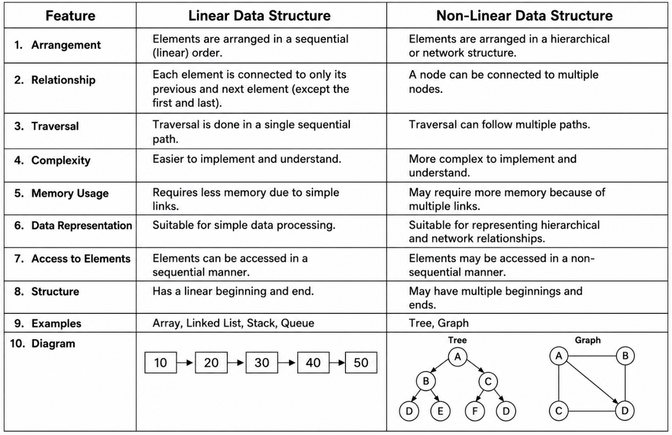

3. Define Abstract Data Type (ADT).
An Abstract Data Type (ADT) is a data type that describes what data is stored (attributes) and what operations (functions) can be performed on that data, without describing how the data is stored or how the operations are implemented.
It focuses on the behavior of the data type rather than its implementation.
Components of an ADT
1. Attributes (Data)
Attributes are the data or properties that an ADT stores.
Example: Stack ADT
- Elements stored in the stack
- Top position (index of the top element)
2. Functions (Operations)
Functions are the operations that can be performed on the data.
Example: Stack ADT
- push() – Inserts an element.
- pop() – Removes the top element.
- peek() – Returns the top element.
- isEmpty() – Checks whether the stack is empty.

3. What is an array-based sequence?
An array-based sequence is a collection of elements stored in consecutive memory locations, where each element can be accessed directly using its index. Arrays are called linear data structures because their elements are arranged sequentially, one after another. An index is the position of an element in an array. In most programming languages, indexing starts from 0.
Eg:
Array = [10, 20, 30, 40]
Index = 0 1 2 3

4. What are the operations on an array?
Traversing: Every data structure contains the set of data elements. Traversing the data structure means visiting each element of the data structure in order to perform some specific operation like searching or sorting.
Insertion: Insertion can be defined as the process of adding new elements to the structure at any location. If the size of data structure is n then we can only insert n-1 data elements.
Deletion: The process of removing an element from the data structure is called deletion. We can delete an element from the data structure at any random location. If we try to delete an element from an empty data structure then underflow occurs.
Searching: The process of finding the location of an element within the data structure is called Searching. There are two algorithms to perform searching, Linear Search and Binary Search.

5. Define Stack. Give algorithm for PUSH and POP operations in array representation of Stack.(7 Marks)
A stack is a linear data structure that follows the LIFO (Last In, First Out) principle. This means the last element inserted into the stack is the first element removed. All insertion and deletion operations are performed only at one end of the stack called the TOP.
Examples: Stack of plates, browser back button, undo operation in text editors.
Array Representation of Stack
A stack can be implemented using an array.
STACK[MAX] → Array used to store elements.
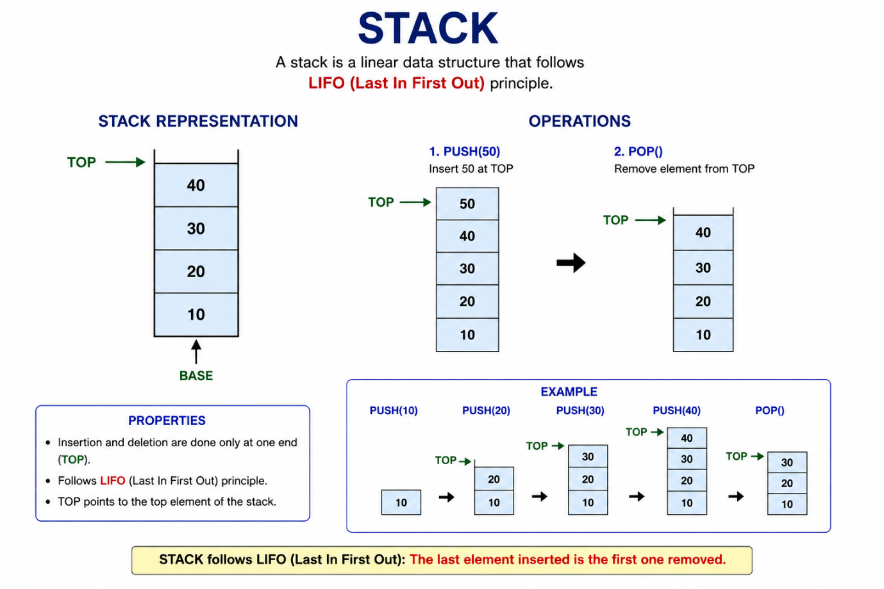

Size:Maximum number of elements the stack can hold. It specifies the capacity of the stack.
Top: Index of the top (last inserted) element. Initially top = -1 because the stack is empty.
s: Pointer to the array that stores the stack elements. It points to the first element of the array.
Operation in Stack
1.Push(): PUSH is the operation used to insert a new element at the top of the stack. Since a stack follows the LIFO (Last In, First Out) principle, every new element is added only at the TOP.
ALGORITH
Step 1: Check if TOP == MAX - 1
If yes, print "Stack Overflow" and stop.
Step 2: Increment TOP
TOP = TOP + 1
Step 3: Insert the new element
STACK[TOP] = ITEM
Step 4: Stop
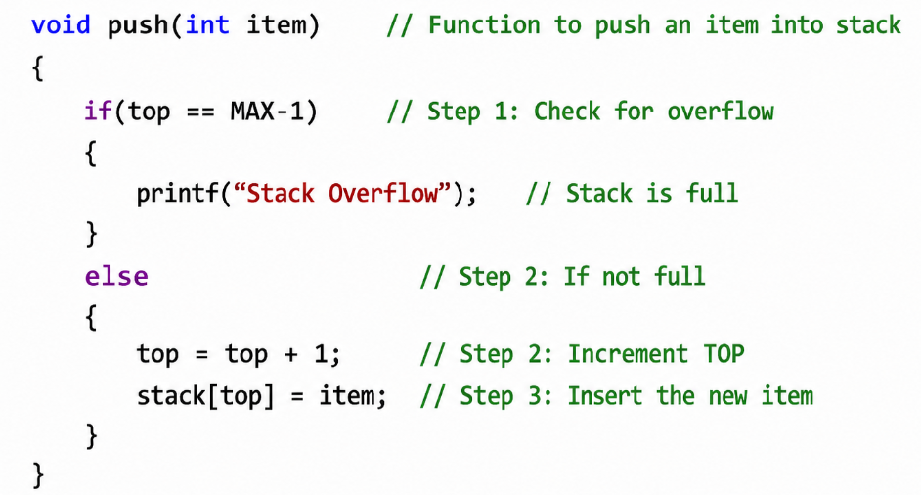

2.pop(): POP is the operation used to remove the topmost element from the stack. Since a stack follows the LIFO (Last In, First Out) principle, the last inserted element is removed first.
Algorithm POP
Step 1: If top = -1 then
Print "Stack Underflow"
Exit
End If
Step 2: item ← stack[top]
Step 3: top ← top - 1
Step 4: Return item
Step 5: Stop

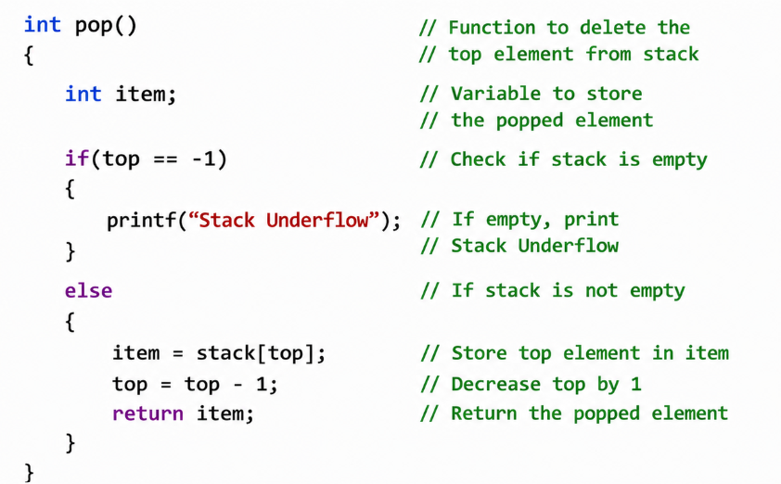

6. Write an algorithm to examine whether the stack is full or empty.
Algorithm: Check if Stack is Full
- Start
- If top == MAX - 1
Display "Stack is Full".
- Else
Display "Stack is Not Full".
- Stop
Algorithm: Check if Stack is Empty
- Start
- If top == -1
Display "Stack is Empty".
- Else
Display "Stack is Not Empty".
- Stop
Conditions Used
- Stack is Full: top == MAX - 1
- Stack is Empty: top == -1

7. The following sequence of operations is performed on the stack : push(1 ),push(2),pop, push(1),push(2). pop, pop, pop, push(2),pop The sequence of popped out values will be................ (3 Marks)
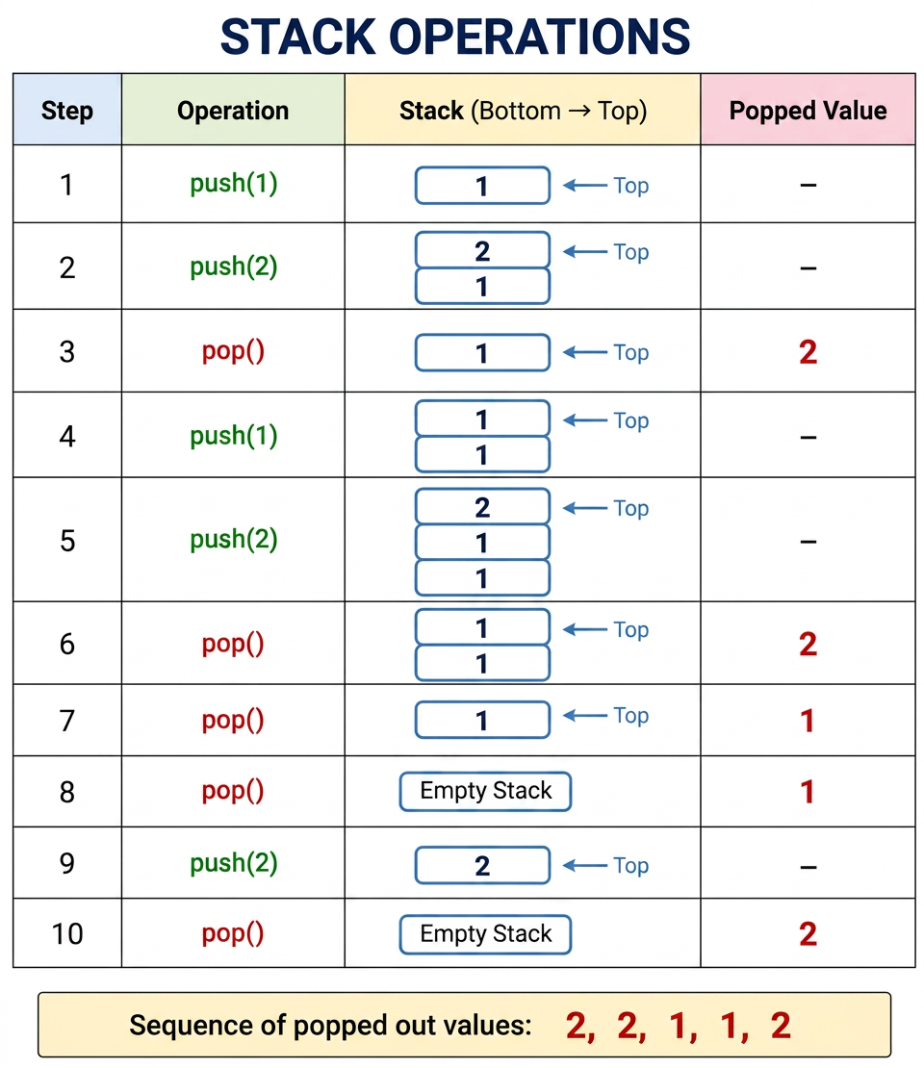

8. Explain the applications of Stacks
Infix to Postfix Conversion:
Infix Expression: An infix expression is an expression in which the operator is written between operands.
Examples:
- A + B
- A + B * C
Postfix Expression: A postfix expression (Reverse Polish Notation) is an expression in which the operator is written after the operands.
Examples:
- AB+
- ABC*+
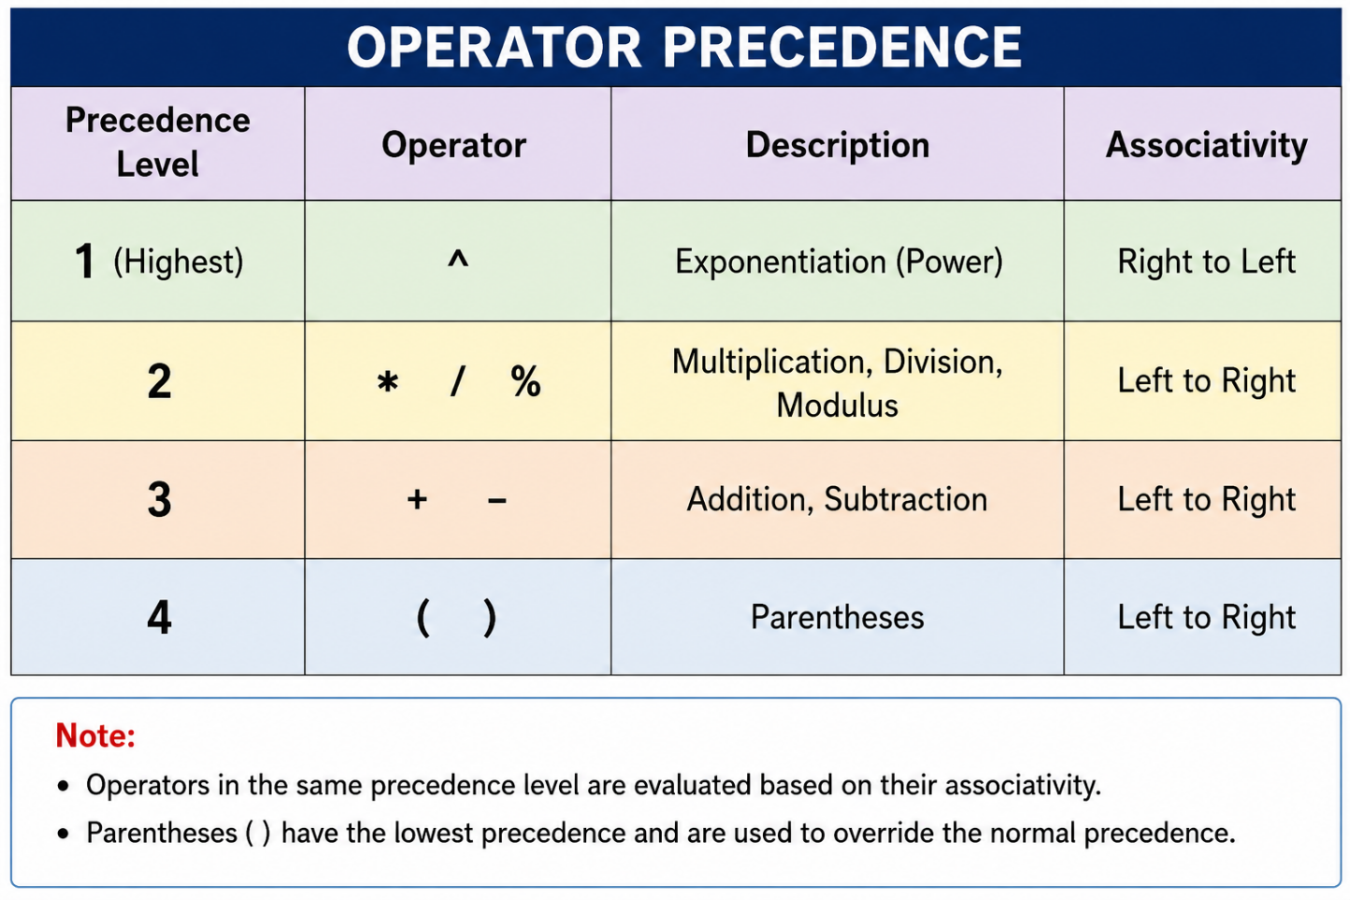

Example: Convert the given infix expression to postfix : A + B * C

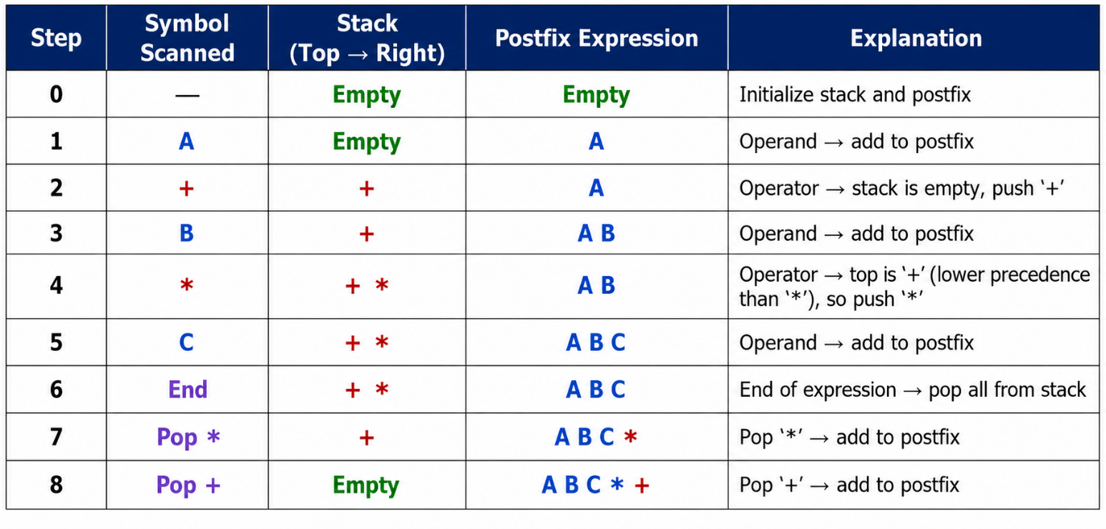
Final Postfix Expression: ABC*+

Algorithm: Infix to Postfix
Step 1: Start
Step 2: Create an empty stack.
Step 3: Scan the infix expression.(left to right)
Step 4: If operand, add it to postfix.
Step 5: If operator
pop higher/equal precedence operators and then push the current operator.
Step 6: Repeat until the expression ends.
Step 7: Pop all remaining operators and add them to postfix.
Step 8: Display the postfix expression.
Step 9: Stop

9.Convert the following infix expression to postfix expression using stack: A+B-C*D. Explain the algorithm.
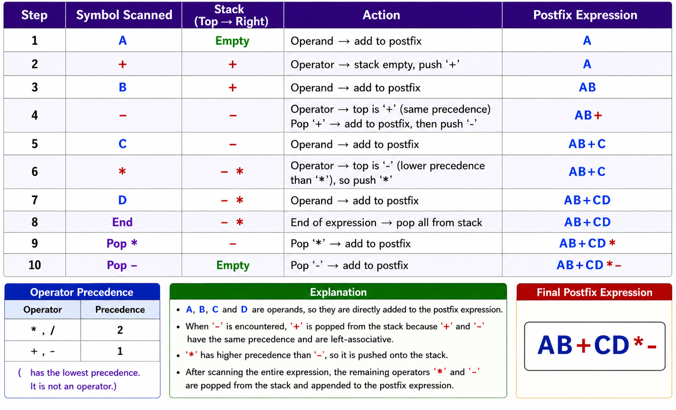
Algorithm: Infix to Postfix
Step 1: Start
Step 2: Create an empty stack.
Step 3: Scan the infix expression.
Step 4: If the symbol is an operand,
Add it to the postfix expression.
Step 5: If the symbol is an operator,
Pop higher or equal precedence operators.
Push the current operator.
Step 6: Repeat until the expression ends.
Step 7: Pop all remaining operators and add them to the postfix expression.
Step 8: Display the postfix expression.
Step 9: Stop
10.Convert the following infix expression to postfix expression using stack: A+B*C/D-E Explain the algorithm.
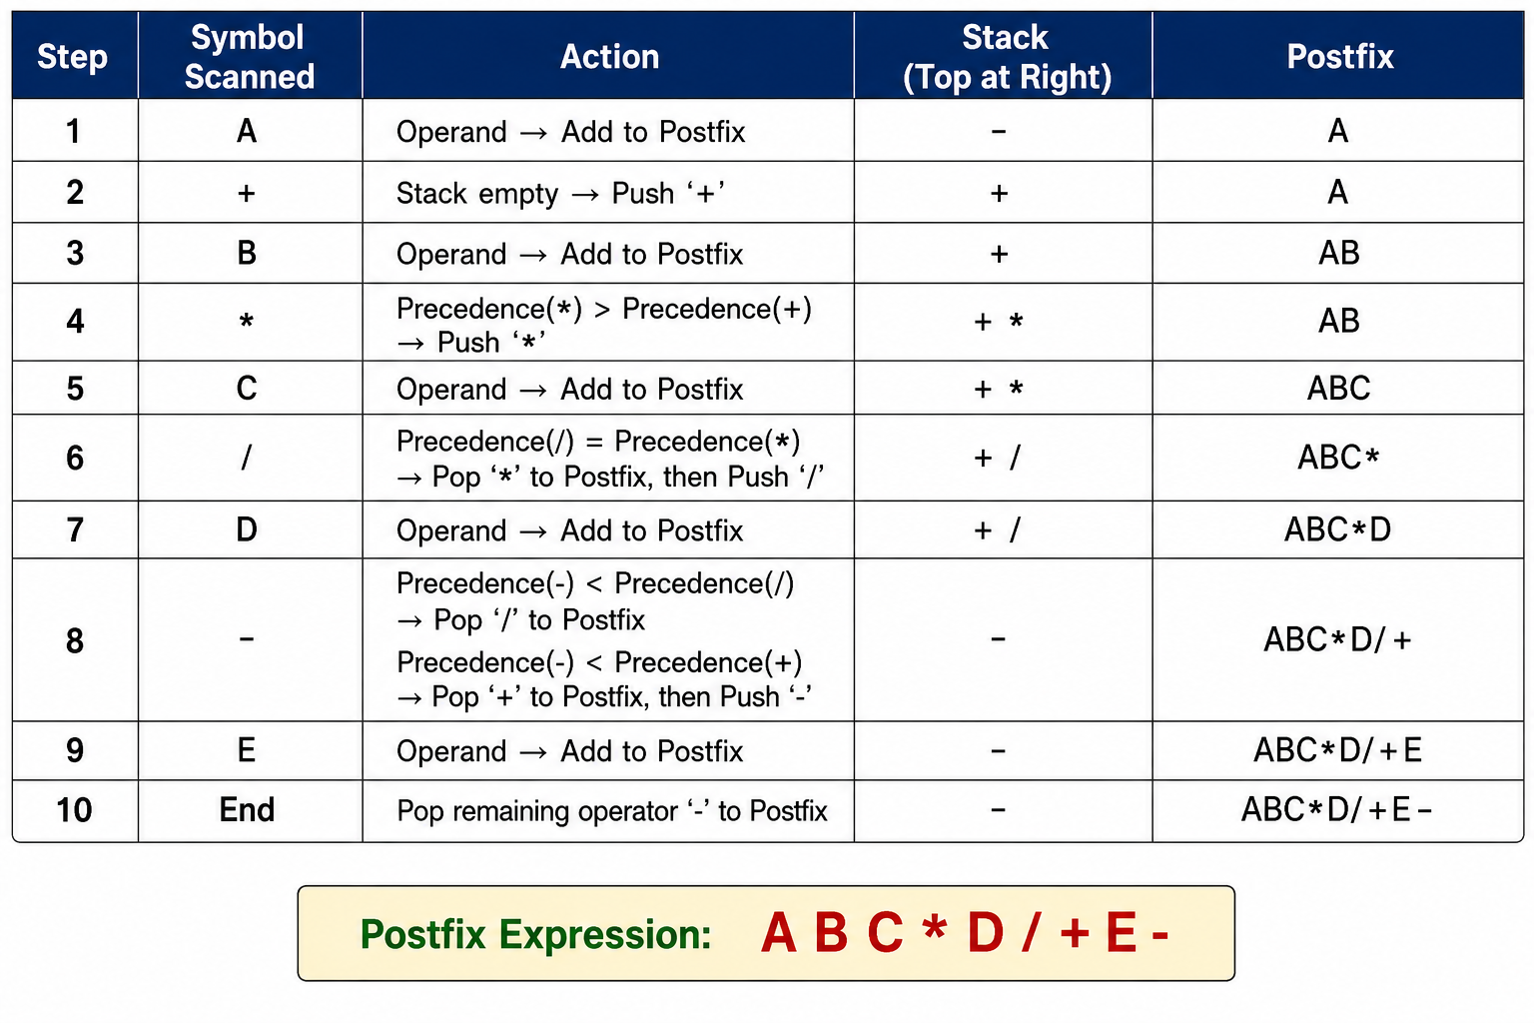
Step 1: Scan the Infix Expression from left to right.
Step 2: If the scanned character is an operand, append it with final Infix to Postfix string.
Step 3: Else,
Step 3.1: If the precedence order of the scanned (incoming) operator is greater than the precedence order of the operator in the stack (or the stack is empty or the stack contains a ‘(’ or ‘[’ or ‘{’), push it on stack.
Step 3.2: Else, Pop all the operators from the stack which are greater than or equal in precedence than that of the scanned operator.
Step 4: If the scanned character is an ‘(’ or ‘[’ or ‘{’, push it to the stack.
Step 5: If the scanned character is an ‘)’ or ‘]’ or ‘}’, pop the stack and output it until a ‘(’ or ‘[’ or ‘{’ respectively is encountered, and discard both the parenthesis.
Step 6: Repeat steps 2–6 until infix expression is scanned.
Step 7: Print the output.
Step 8: Pop & output from the stack until it is not empty.

11. What is a Queue?
A Queue is a linear data structure in which insertion is performed at the REAR and deletion is performed at the FRONT.
A queue follows the FIFO (First In, First Out) principle.
Example:
A queue of people waiting for a bus follows FIFO—the person who comes first is served first.
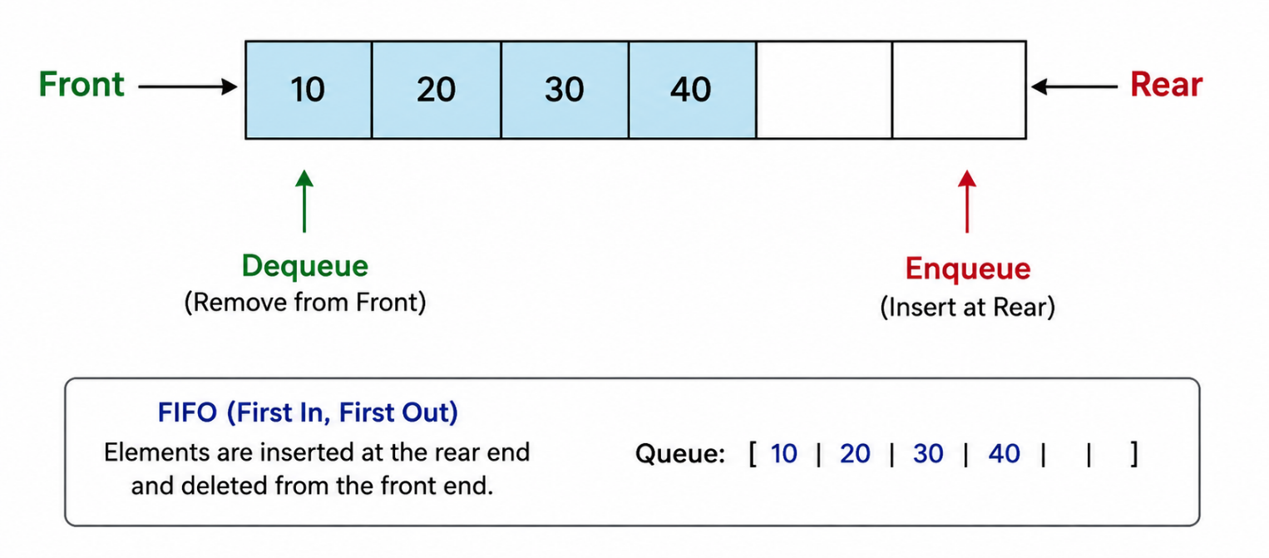
12. What is FIFO?
FIFO stands for First In, First Out.
It means the element inserted into the queue first will be removed first.
Example:
10 → 20 → 30
If dequeue() is performed, 10 will be removed first.

13. What is Queue ADT?
Queue ADT (Abstract Data Type) is a logical model that defines the data and operations of a queue without specifying its implementation.
The main operations of Queue ADT are:
- Enqueue – Insert an element at the rear.
- Dequeue – Delete an element from the front.
- Peek/Front – Access the front element.
- isEmpty() – Check whether the queue is empty.
- isFull() – Check whether the queue is full.
14. What are the basic operations on a Queue?
Enqueue()
Enqueue is the operation of inserting (adding) an element into a queue.
- The new element is always inserted at the REAR of the queue.
- Queue follows the FIFO (First In, First Out) principle.

Algorithm: ENQUEUE(ITEM)
- Start.
- Check whether the queue is full.
- If REAR == MAX - 1, display "Queue Overflow" and stop.
- If the queue is empty (FRONT == -1), set FRONT = 0.
- Increment REAR by 1.
- Insert ITEM into QUEUE[REAR].
- Stop.
CODE
#include <stdio.h> // Include standard input/output library
#define MAX 5 // Define the maximum size of the queue
int queue[MAX]; // Declare an array to store queue elements
int rear = -1; // Initialize rear to -1 (queue is empty)
void enqueue(int value) // Function to insert an element into the queue
{
if (rear == MAX - 1) // Check whether the queue is full
{
printf("Queue Overflow\n");
}
else
{
rear++; // Move rear to the next position
queue[rear] = value; // Insert the value at the rear
printf("%d inserted into the queue\n", value);
}
}
int main() // Main function
{
enqueue(10); // Insert 10 into the queue
enqueue(20); // Insert 20 into the queue
enqueue(30); // Insert 30 into the queue
return 0; // End the program
}
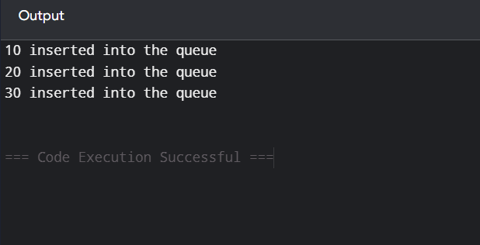

Dequeue(): Dequeue is the operation of removing an element from the front of a queue. It follows the FIFO (First In, First Out) principle. If the queue is empty, the operation results in underflow.

Step 1: Start.
Step 2: Check if FRONT > REAR.
Step 3: If true, display "Queue Underflow" and go to Step 6.
Step 4: Otherwise, delete the element at QUEUE[FRONT].
Step 5: Increment FRONT by 1.
Step 6: Stop.
CODE
#include <stdio.h> // Include standard input/output library
#define MAX 5 // Define maximum size of the queue
int queue[MAX] = {10, 20, 30}; // Declare and initialize the queue
int front = 0; // Initialize front to the first position
int rear = 2; // Initialize rear to the last element
void dequeue() // Function to delete an element
{
if (front > rear) // Check whether the queue is empty
{
printf("Queue Underflow\n");
}
else
{
printf("%d deleted from the queue\n", queue[front]);
front++; // Move front to the next position
}
}
int main() // Main function
{
dequeue(); // Delete 10 from the queue
dequeue(); // Delete 20 from the queue
return 0; // End the program
}
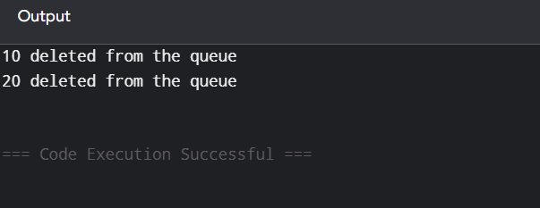

15. What is Queue Overflow and Queue Underflow?
Queue Overflow
Queue overflow occurs when we try to insert an element into a full queue.
Example:
If the queue size is 5 and all 5 positions are occupied, another enqueue() causes overflow.
Queue Underflow
Queue underflow occurs when we try to delete an element from an empty queue.
16. Differentiate Stack vs Queue
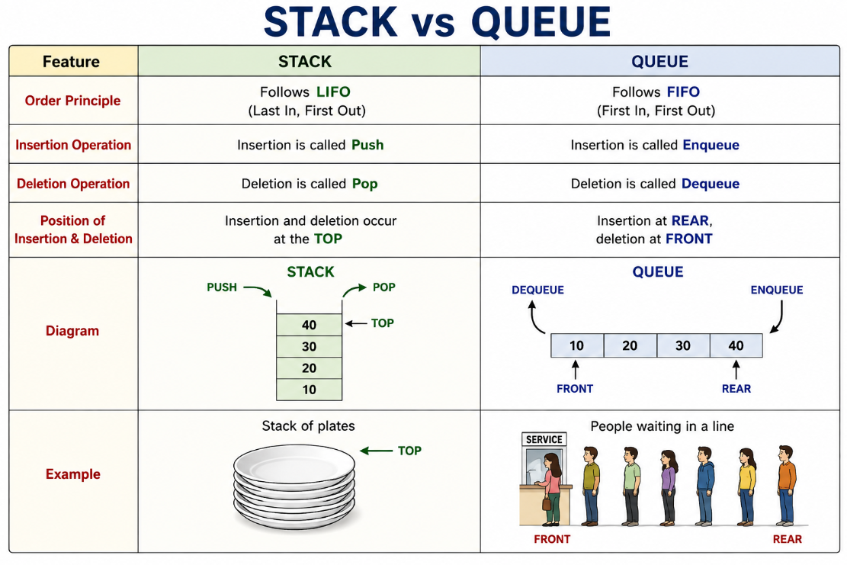
16.What is a pointer?
A pointer is a special variable that stores the memory address of another variable. It allows us to access and modify the value stored at that memory location. In C, pointers are declared using the * operator.
Example: int *p;
Eg:
int x = 10;
int *p = &x;
Here:
- x stores the value 10.
- &x gives the address of x.
- p stores the address of x.
- *p gives the value 10.
So:
p → address of x → 10
18.What is a structure in Data structure?
In C programming, a structure (struct) is a user-defined data type that allows you to store different types of data together under one name.
Example:
struct Student
{
char name[20];
int age;
float marks;
};
Here, Student contains three different types of data:
- name → character/string
- age → integer
- marks → float
19. Write a structure variable to store the details of student with Student name, register number and marks
struct Student {
char name[50]; // To store student name
int reg_no; // To store register number
float marks; // To store marks
};
17. Convert A + (B * C - D) / (E - F) into postfix using a stack.

Basic Rules
- Scan the expression from left to right.
- If the scanned character is an operand (A, B, C, 1, 2, 3), add it directly to the postfix expression.
- If the scanned character is (, push it onto the stack.
- If the scanned character is an operator (+, -, *, /, %):
  - If the stack is empty, push the operator.
  - If the top of the stack has lower precedence, push the new operator.
  - If the top of the stack has higher or equal precedence, pop the operator from the stack and add it to the postfix expression, then push the new operator.
- If ) is encountered, pop operators from the stack and add them to the postfix expression until ( is found.
- Discard the parentheses ( and ); they are not included in the postfix expression.
- After scanning the entire infix expression, pop all remaining operators from the stack and add them to the postfix expression.

